

HUMBLE SIGN
HUMBLE CONFIGURE

Login to Role: Sales Manager
Configure Creation:

Humble Configure: It is a record that allows users to estimate the costs associated with creating an Assembly Item (material and process costs), while also automating the generation of a rough-cut Bill of Materials (BOM), Revisions, and Routing. Furthermore, users can create quotes based on the estimated selling price calculated using Humble Configure.

To create a Configure the user needs to
Navigate to Opportunities -> Transactions -> Humble Configure -> New

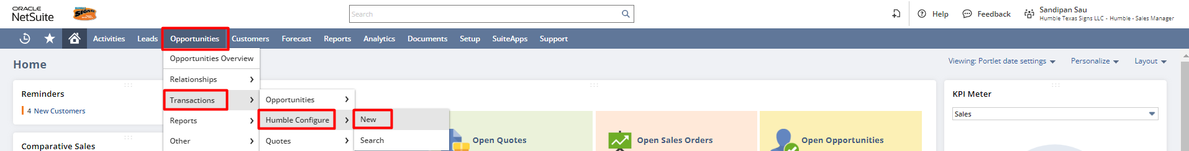

Or for the list of all the Humble Configures,
Navigate to Opportunities -> Transactions -> Humble Configure

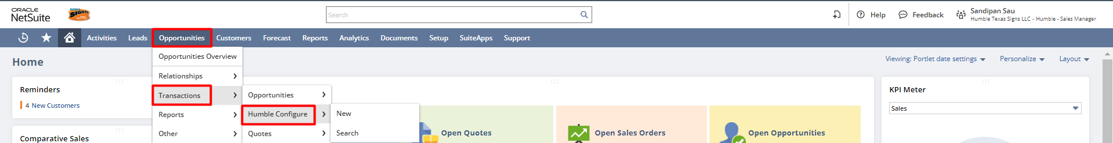

In the Humble Configure record, the user needs to enter all the necessary details. Select the Assembly Name, Customer check the “Lot Numbered Item” checkbox you want to create a Lot Numbered Assembly Item from Humble Configure by default it will create a Serialized Assembly Item, or select it as anonymous if the customer is not defined yet. Enter the Order Quantity, Unit Type select Location. Enter the Description and modify the Markup(%) (if required).

The value in the Assembly Name field is used as the name of the new Assembly when generated from Humble Configure. User will need to define the Assembly Name by unchecking the Auto checkbox and adding the Assembly Name in the field. (Here, we have used the name of the assembly item). User needs to enter the name of the Assembly which they would like to Quote. User must ensure that the name of an existing Assembly is not used if they would like to generate a new assembly using the Humble Configure. They would receive an error if the name of an existing assembly is used.

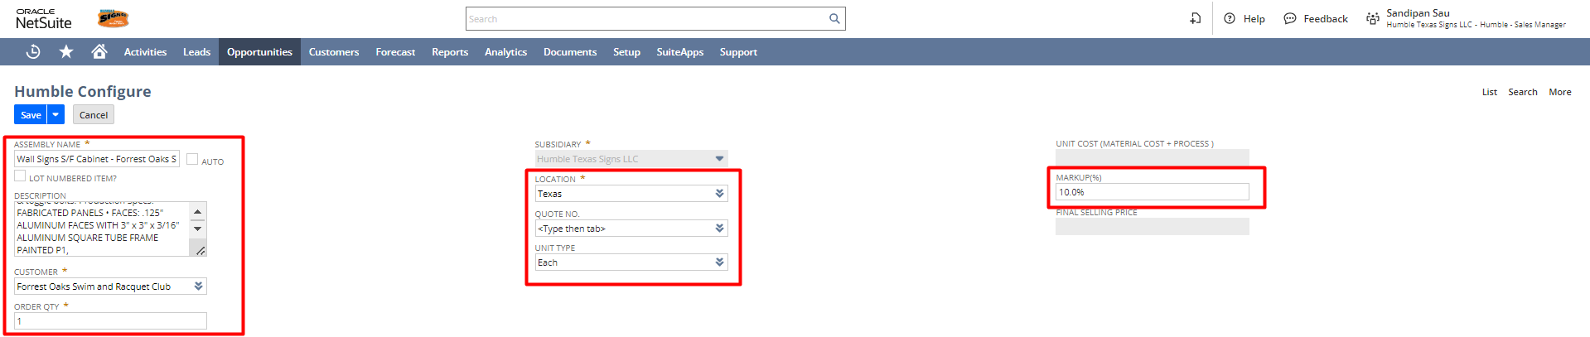

Under the Items subtab select the Components for the new Assembly Item and enter their Quantity Per Unit, Unit Cost, Unit Price. The Unit Cost would automatically source from the Purchase Price of the selected component, and the Unit Price would automatically source from the Base Price of the selected component. If the Unit Cost & Unit Price is not present for an item, provide the Unit Cost & Unit Price for the component. The total cost and the total price will be calculated as follows

Total Cost: Quantity Per Unit * Unit Cost of that Component
Total Price: Quantity Per Unit * Unit Price of that Component

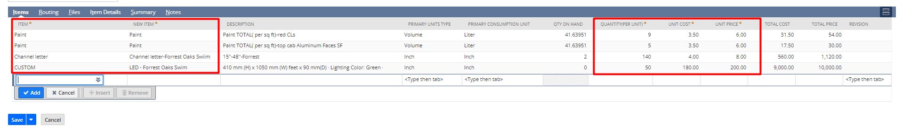
If any of the inventory items required to create the quote the Assembly item is not present in the system, then select Custom (For Plain Inventory Item) / Custom Lot Numbered (For Lot Numbered Inventory Item) from the Item dropdown, enter the Item name for the item to be created in the New Item field, select the Units Type, enter a Description and Unit cost, Unit Price. Once the Humble Configure record is saved, system will automatically create a new Inventory Item and then use in setup of the new revision for the Assembly.
If Channel letter – NEED TO UPDATE THE WORDING

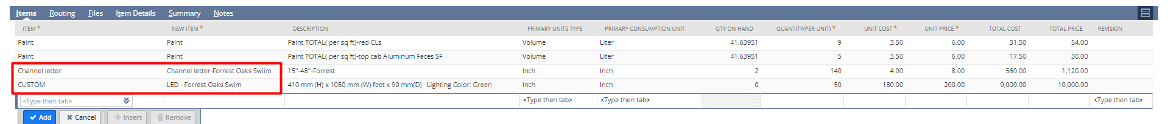

Under the Process Steps subtab, select the Routing template if it’s already created otherwise click on New for create a new Routing template.
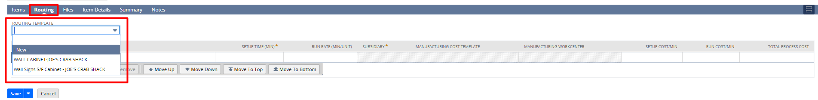
In Routing template record enter the Name, under the Routing Step tab enter Operation Sequence, Process, Setup Time, Run Rate and click on Save.
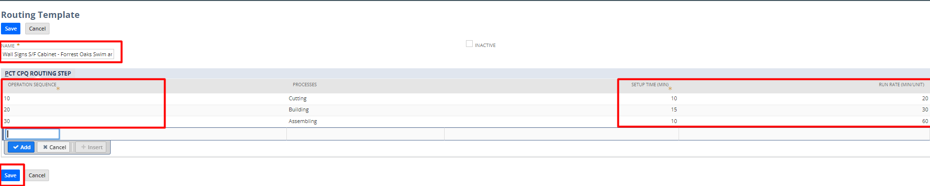
Based on the selected process in the Routing template, the Subsidiary, Manufacturing Cost Template, Manufacturing Work Center would get sourced automatically, however you also have the ability to change that manually.
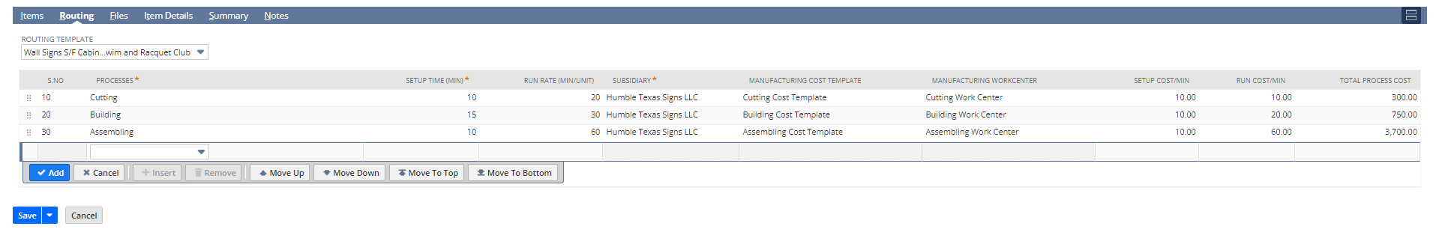
Click on Save to create the Humble Configure.
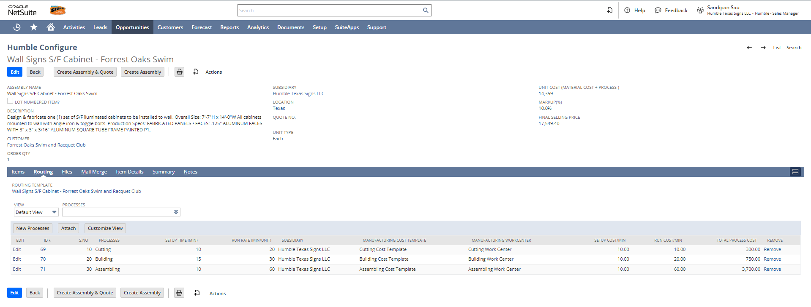

Once the record is saved, system will automatically calculate the Total Processes Costs, Total Markup Cost, Total Material Cost, Unit Cost and Final Selling Price after Markup based on provided inputs.
Under the Summary subtab, user can see the Total Material Cost, Total Process Costs, and Total Markup Cost, and in Humble Configure main tab user can see the Unit Cost and Final Selling Price. The costs and prices will be calculated as follows:
Total Material Cost: Sum of all the total costs of the Components.
Total Process Cost: Sum of all the total process costs.
Unit Cost (Material + Process): Sum of total Material Cost and the total Process Cost.
Total Markup Cost: Markup percentage on the Unit Cost.
Final Selling Price: Sum of all the total price of the Components + Total Process Cost + Total Markup Cost

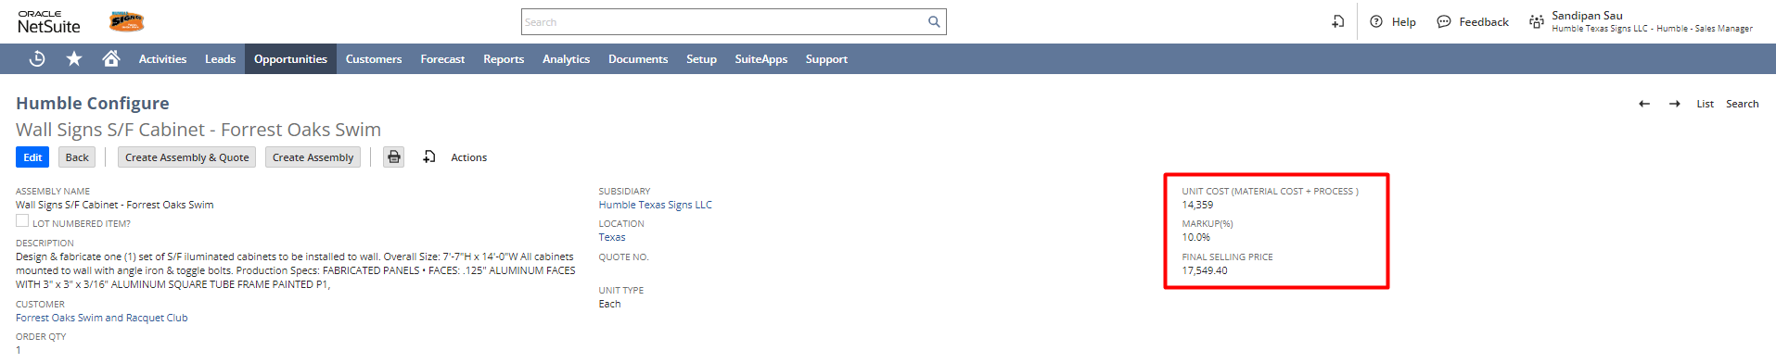

If everything seems correct, we can proceed into next steps. Click on the Create Assembly button, this will create the new Assembly Item and its corresponding BOM, Revision, and Routing. Users can see the Lot Number Assembly Item, BOM, and BOM Revision under the Item Details subtab.

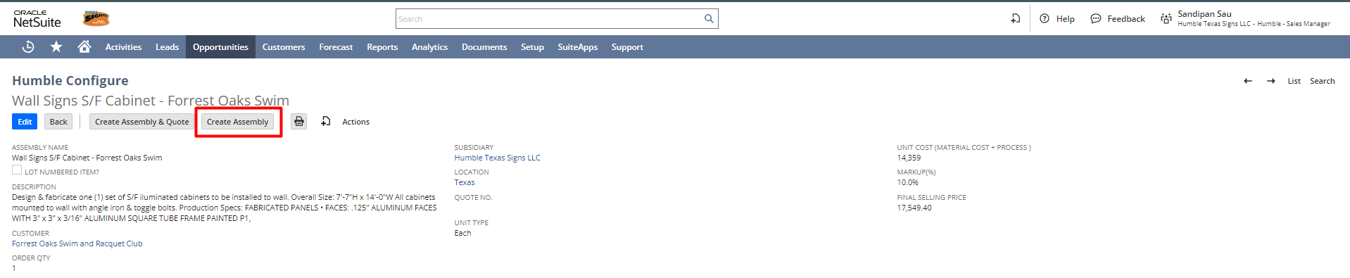

To also Create a Quote along with the Assembly Item, BOM, BOM Revision, Manufacturing Routing click on Create Assembly & Quote button.

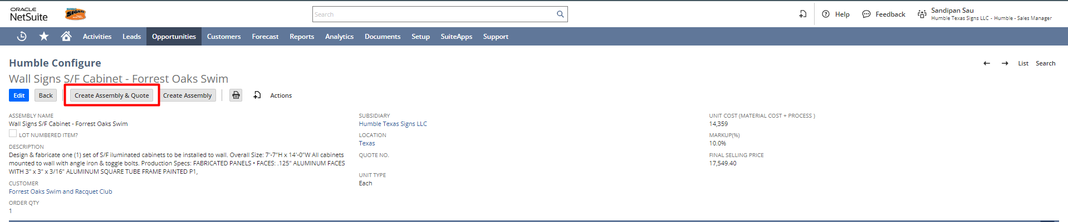

After clicking on the Create Quote & Item button, a Serialized/Lot-Numbered Assembly Item, BOM, BOM Revision, and Manufacturing Routing will be created.

Users can see the Serialized/Lot-Number Assembly Item, BOM, and BOM Revision under the Item details subtab.
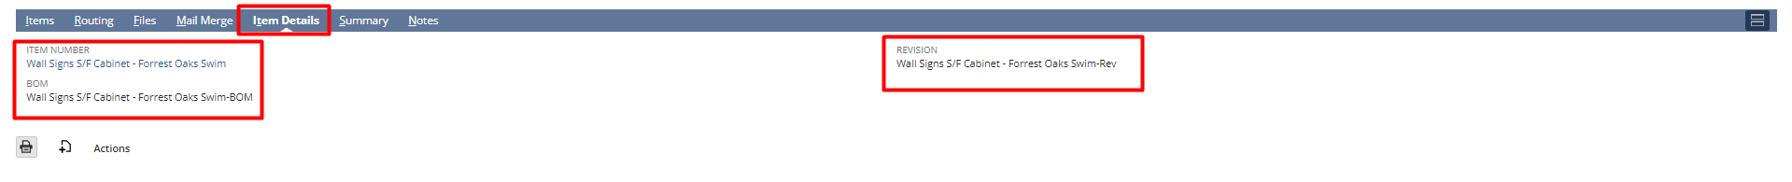
And the Quote will be attached to the main tab of Humble Configure on the Quote No field.
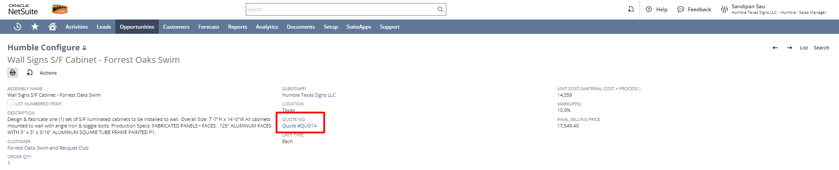

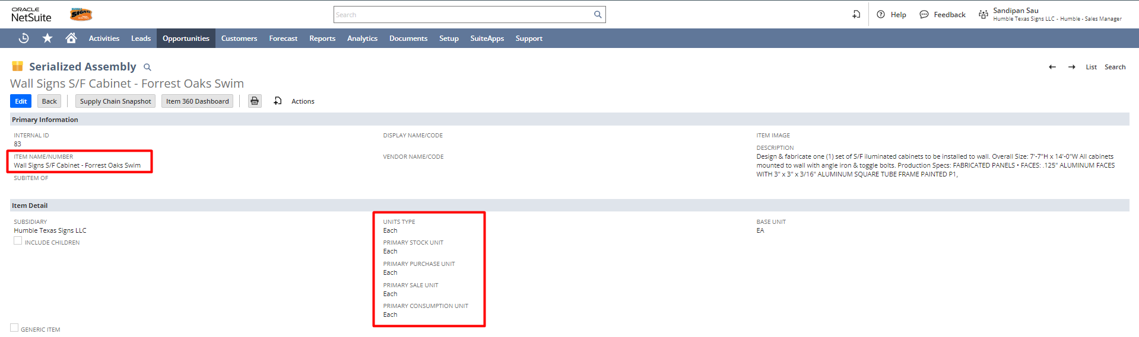

BOM (Created with the name of Lot-numbered Assembly Item with a suffix of “-BOM”)

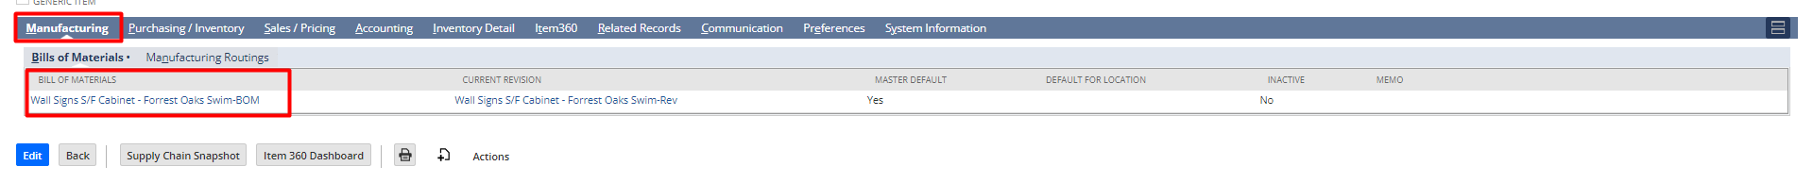

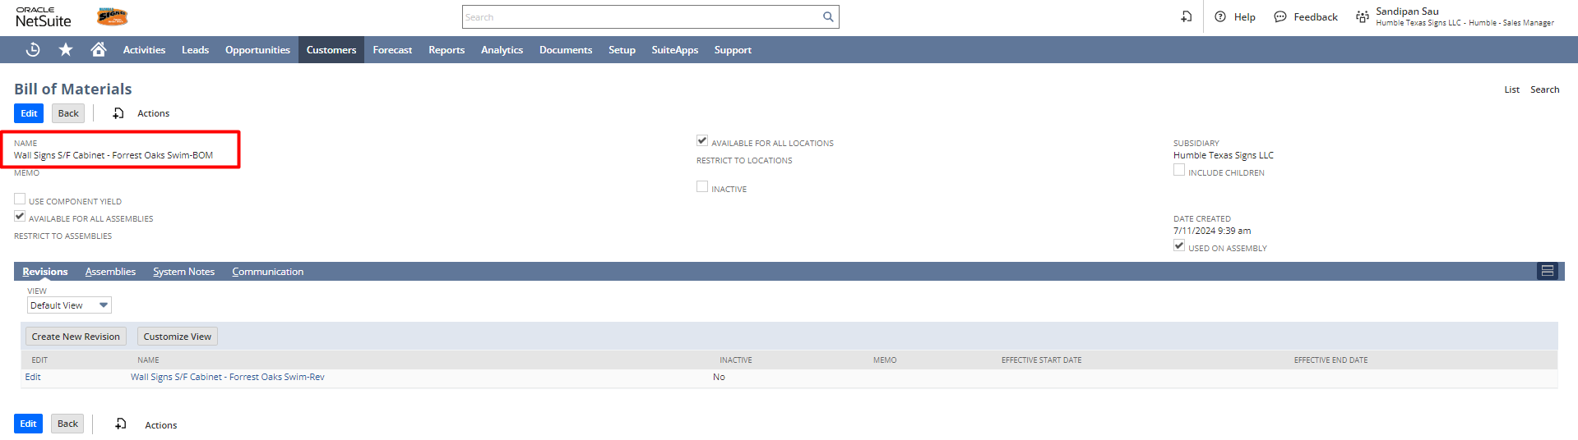

BOM Revision (Created with the name of Lot-Numbered Assembly Item with suffix of “-REV”)

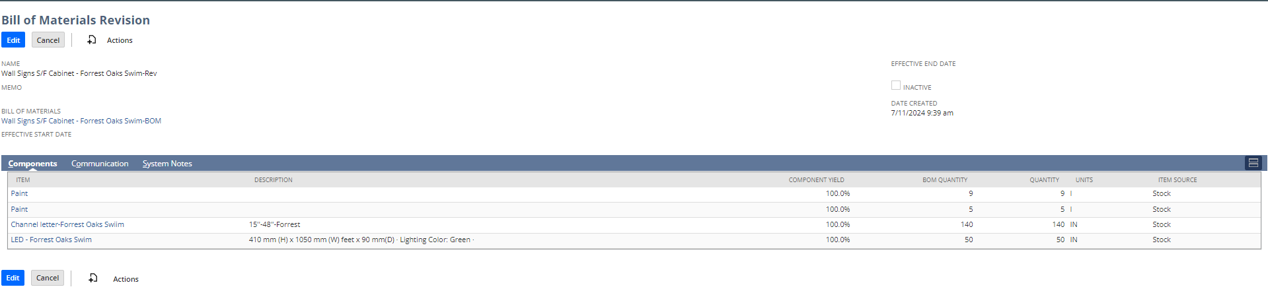
Manufacturing Routing (Created with the name of created Lot-Numbered Assembly Item with a suffix of “Routing”)

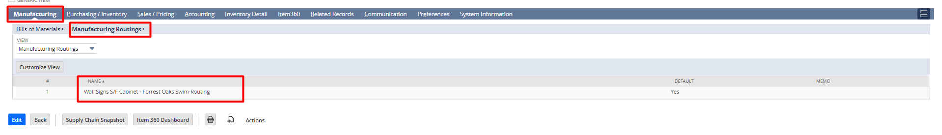
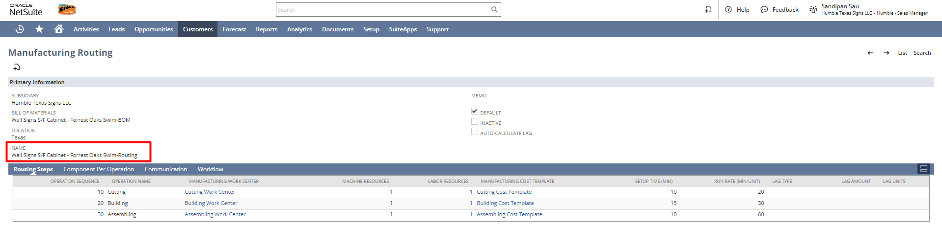

A Quote will be created with the Lot number Assembly Item. Customer, Item, Quantity (In Humble Configure Order Qty) and Unit Price (In Humble Configure Final Selling Price) will be fetched from Humble Configure.

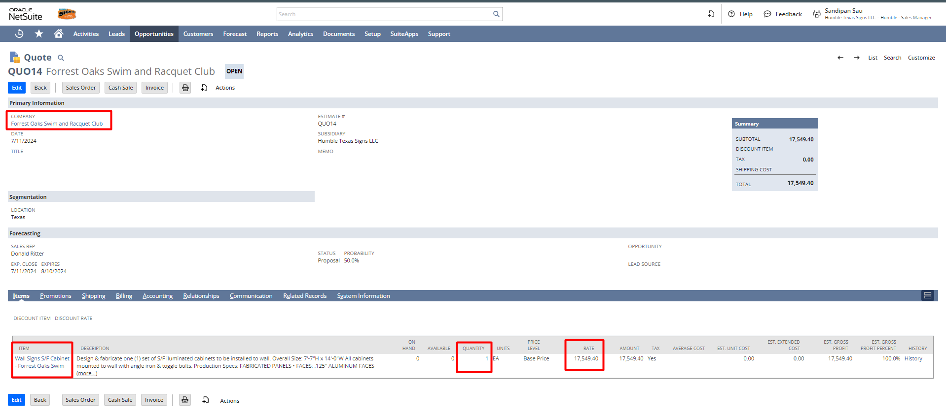

Signature: ______________________ Date: ______________________

Disclaimer:
Upon signing off on the document, you are confirming that the process has been set up per the SOW within NetSuite per your business’s needs. Any changes or modifications requested after sign-off will need to be a “change request” at an additional fee.

***PLEASE ensure that you have logged into NetSuite and tested the process prior to signing off on the setup. Paapri requires sign-off on this document prior to moving forward with any additional design meetings.

